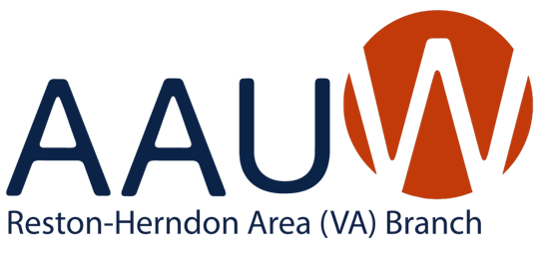
President’s Pen
Time feels like it is moving along at super speed this year! The weather is warming, days are lengthening and flowers are springing out of the ground. Reston-Herndon AAUW still has a lot in store before our year ends, so please be sure to read every page so you don’t miss out on anything that you might want to know about and be a part of.
AAUW Vote
I hope you have already taken the opportunity to make your voice heard by voting on our AAUW bylaw concerning the elimination of the educational requirement and opening AAUW to all. We as an organization say that we value inclusion, yet as a result of this requirement, our organization is not inclusive. However you feel about this important issue, the most important thing to do is to VOTE! Here are the particulars on our opportunity to vote:
  - Voting has already started online.
  - Most members received emails from vote@simplyvoting.com with their unique Elector ID and Password to vote. If you cannot find this, notify the national office immediately.
  - All members without an email address on file or who have unsubscribed from AAUW national emails have received a paper ballot by mail. No additional paper ballots will be sent during the voting period.
  - Voting will close on Wednesday, May 15 at 12:00 pm ET.
Join Us at the Annual Meeting to Vote in Your New Slate of Officers
Be sure you check out the article on the slate of Officers for Reston-Herndon Area Branch that will be voted on during our Annual Meeting. As you can see, there are positions still unfilled. If you decide you are interested in adding your name as an officer of our branch, you can do so at our Annual Meeting on June 5. The officers would love to have you join their ranks. See the article about the Annual Meeting, and be sure to signup to attend!
Finally, thank you for allowing me to be the Co-administrator and Administrator for the past few years. It has been an honor to represent Reston-Herndon Area AAUW to our national and state leaders as well as to serve as your administrator. I appreciate your confidence in my abilities. I know that our new slate of officers, all of whom are tenured will serve the branch and move us forward in amazing ways!
Please read the rest of this newsletter to learn about all the activities that are planned for this spring and summer.
Cyndi Shanahan
Administrator, Reston-Herndon Area Branch
MEMBERSHIP NEWS- Judi Polizzotti, VP Membership

Currently, we have 61 members in our branch. We hope to promote College/University membership and consider strategies for increasing membership in the future. Members are encouraged to bring a friend to meetings and programs to introduce them to our branch activities and priorities.

Members Supporting Members

We often have requests to keep members apprised of serious illnesses/deaths in the family within our branch community. Your help is needed with this issue. Please provide the names, contact information (especially important if the individual is not at home) and any additional information she permits when you become aware of those who need our support due to personal circumstances. Please provide all information to our President Cyndi Shanahan. The branch members will be notified as soon as possible. Please support those individuals who are in need with cards, meals, visits, etc.

PUBLIC POLICY- Shyamali Hauth, Chair

Thank you for your advocacy work during the Virginia General Assembly regular session.
The Virginia General Assembly reconvened for the day on April 17, 2024. As predicted, they were unable to find the 2/3 vote necessary to override the Governor’s vetoes.
Bills Passed and Signed
  - HB894 Expanding electronic meetings
  - HB78 Privacy for “menstrual tracker” apps
  - HB831 Expansion of Maternal Health Review teams
  - HB890 Support referral for higher education students reporting bullying
  - SB101* Same sex marriage protections added to code
  - HB48 Ending Legacy Admissions in state higher education
  - HB994 which ends child marriage which was often a path to sex trafficking
Bills Passed but Vetoed by the Governor
- HB990/SB370 Salary history ban
- SB373 Paid Family and Medical Leave
- HB 569 Notification of deadlines to file state and federal discrimination claims
- HB1/HB1 Minimum Wage increase
- HB519 Ban disciplinary action against doctors for providing abortion care
- SB15 Extradition ban for abortion care related services
- SB14/HB805 Local sales tax to support schools and a similar House bill to allow more flexibility in local school funding
Much remains in play in the budget, however, with both the GA negotiators and the Governor agreeing to set aside their budget proposals and meet to negotiate a new budget to be unveiled on May 13. The General Assembly would then reconvene on May 15.
AAUW National will be doing a major voter engagement and education project through the November election. We will be doing postcards as usual but also other advocacy work with the League of Women Voters. Stay tuned for details.
On April 19, the Department of Education issued a final Title IX rule clarifying protections for survivors of sexual harassment and assault, pregnant and parenting students, and LGBTQ+ students. The AAUW joined partner organizations to commend the administration for listening to experts in the field in issuing the rule, while also acknowledging further work remains to ensure protections for all student athletes. Currently 37% of transgender, nonbinary, and intersex youth live in states with laws banning them from participating in sports consistent with their gender identity.
WEBSITE RESTON-HERNDON BRANCH - Dianne Mero
Looking for something in particular about our branch?
Our branch website can be found at https://restonherndon-va.aauw.net (or by searching (Reston-Herndon AAUW’ in your web browser). This site is a great “back-up” to this newsletter (edited by Roberta Sherman) and the weekly branch highlights (thanks to Janine Greenwood) which are both sent to all branch members. You can make sure your email address is up to date in the National database by reviewing your AAUW Hub “Snapshot” page information or check with Membership VP, Judi Polizzotti, and you will also receive all AAUW of Virginia member notices. In addition to timely posting of branch activities, events, and mission-related information, on the website you can learn about local, state and national AAUW priorities and how to become involved at each level. Additionally, there are various articles and photos posted and a current calendar of events and programs in case you have misplaced or wish to double-check information about branch events. The website also has a restricted “Members Only” section, requiring an entry code [VA3035], with member contact information including individual email addresses of members and officers and other branch information. Give it a look and while you're there, verify your contact information and let Judi know if there are any errors. Thanks, Dianne

BOOK GROUP Alyse Goldman and Carla Heymsfeld
Book group meets the fourth Wednesday of every month except November. Check the weekly announcements online to see either the zoom link or where the group will meet.
May: Lessons in Chemistry, by Bonnie Garmus
June: The Premonition, by Michael Lewis
July: In the Form of a Question, by Amy Schneider
August: Siracusa, by Delia Ephron
September: Heaven and Earth Grocery Store, by James McBride
October: History of Home Economics, by Danielle Dreilinger
December: The Lost Manuscript, by Cathy Bonidan

Diversity Equity Inclusion Patty Hagan, Chair
The DEI program on March 16 about “Exploring Gender: Conversations with a Trans Person” was excellent! The speaker, Lindsay Lowry (they/he), provided a very interesting presentation and answered questions for over 90 minutes. They explained the terms on a slide answering many questions about the differences between those words and other more commonly used words. They explained the importance of asking for people’s preferred pronouns upon meeting them and providing them with your own. Lindsay understood that this is not something that’s common for the attendees; they encouraged us to practice it to make it easier. They also said that adding our pronouns on signatures and things link our Zoom picture helps people
Lindsay also talked about situations within his own family and how they’re adjusting. He said pronouns are often the hardest thing for people to remember. Like with most things we’re learning, practicing helps using the correct pronouns. They said that when we make mistakes, apologize, correct ourselves, and practice.
Lindsay’s talk resonated with some attendees who have trans people in their families. Lindsay explained that trans people have been with us throughout history. In some cultures, they were honored. In the US, our indigenous people referred to them as “Two Spirited” and were often considered special. Trans people weren’t included in our history book though, like so many others.
Some of the information in the guide Lindsay provided were adapted from the Trevor Project website, www.trevorproject.org. That website provides resources for youth who are LGBTQ+ including counselors and connecting with similar youth.
Lindsay left us with several resources to watch or read to continue our education. They are:
- Disclosure (Netflix)
- Gender Revolution with Katie Couric (Disney +)
- Paris Is Burning (Max)
- Transgender History – Susan Stryker
- Redefining Realness – Janet Mock
- Stone Butch Blues – Leslie Feinberg
- Authentic Selves: Celebrating Trans and Nonbinary People and Their Families – interviews by Peggy Gillespie
May is recognized as Asian Americans, Native Hawaiians, and Pacific Islanders Month. This month has been federally recognized since 1990. Previously, it was only a one-week designation. The theme for 2024 is “Advancing Leaders Through Innovation.” This is the culmination of the Advancing Leaders series that began in 2021.
"Advancing Leaders Through Innovation," pays homage to the visionaries and trailblazers who have shaped our AANHPI history and continue to influence our collective future. Innovation, resilience, and a pioneering spirit are cornerstones of American leadership. AANHPI leaders have made lasting contributions to our Nation’s economic prosperity, technological advancements, and social/political change through their ingenuity and creativity while navigating significant cultural and systemic barriers.” (https://fapac.org/pressreleases)
The Federal Asian Pacific American Council (FAPAC) has an extensive resource center available at https://fapac.org/AAPI-Resources.
May is also Jewish American Heritage Month and Mental Health Awareness Month. There’s an excellent article on Jewish Americans at https://nationaltoday.com/jewish-american-heritage-month. And NAMI (National Alliance on Mental Health) has a wealth of resources on its website: https://www.nami.org/Get-Involved/Awareness-Events/Mental-Health-Awareness-Month)
June is Pride Month in recognition of the response to the Stonewall raid in June 1969 (https://tinyurl.com/2rytn4h4). While this wasn’t the first-time people who are LGBTQ+. fought back against police raids and misconduct, Stonewall got the attention of people outside that community who began to understand and support people who are LGBTQ+.
There are many themes for Pride month. DC Pride’s Theme is “Totally Radical” which “…embraces the vibrant energy of the LGBTQ+ community and pays homage to the radical spirit that defined the activism and progress of the 1980s and ‘90s.” (https://tinyurl.com/3cy5b5t7). New York City has proclaimed its theme as “Reflect. Empower. Unite”. And Chicago has chosen “Pride is Power!” as its theme. Many other cities have designated their own themes. The various themes represent the strength within and increased support for the LGBTQ+ community as well as the struggles it still faces.
Reston will celebrate Pride month on June 1 from noon to 6 on Lake Anne Plaza. (https://restonpride.org) It’s a wonderful celebration with food, entertainment, crafts and more.
On Juneteenth (June 19), we also celebrate when the news of the Emancipation Proclamation finally reached enslaved people in Galveston, Texas. It was two and a half years after President Lincoln had issued the proclamation.
Here in northern Virginia, we are lucky to be surrounded by people from all over the world. We have so many ways to learn about different cultures and heritages. Check online and your local sources for ways to learn more and celebrate the diversity around us!

Adopt a Spot - Saturday May 18, 2024 at 4:00 pm
Fran Lovaas, Chair
In 2008, the Reston/Herndon Branch of AAUW revived the Branch Adopt A Spot Program and began to clean the path and roadway along North Shore Drive, from the Uplands Pool to Wiehle Avenue. This path was chosen because it abuts Forest Edge Elementary School, where our Branch Mentoring Program took place for many years. Two times a year (one time in the Fall and one in the Spring) six to ten AAUW volunteers head out to pick up trash and recycling along this pathway. The Reston Association provides the trash grabbers and the trash and recycling bags. The whole exercise only takes a little over an hour.
This program was suspended for awhile due to COVID and other circumstances, but we plan to start up again in 2024. We will meet at the Uplands Pool for a clean-up session on Saturday, May 25th at 4:00 pm. If you are interested in joining us, or if you need more information please contact Fran Lovaas at franlovaas@comcast.net or call (703)463-6554.
Thank you - It’s also always good to know that you are helping to take care of Mother Earth.

Reston-Herndon Area Annual Meeting
June 5
11:30 – 1:30
Cafe Montmartre – Lake Anne Plaza

Please plan on attending the Reston-Herndon Area branch annual meeting. It will be held at Cafe Montmartre at Lake Anne Plaza, Reston. During the meeting we will spend time socializing and we will also vote in our new slate of officers for the 2024-25 season.
By May 31:
- Mark your calendar for June 5 at 11:30
- Send Cyndi Shanahan (cyndi9817@gmail.com) an email with you lunch selection from the options below,
- Send a check to Ruth Ruttenberg for $28 which will cover the cost of your lunch, including a beverage and tip. Ruth’s address is:

1767 Wainwright Drive
Reston, Va 20190
Luncheon Options:

1 - Salade Nicoise
2 - Quiche Lorraine
3 - Viet ‘Bánh Mì’ with Chicken

Education Committee
Roberta Sherman, Chair
The Education Committee has been busy with ordering and presenting books to our local schools. With the help of area librarians, we have chosen and delivered books to South Lakes High School (see picture below) and have ordered books from the series Leading the Way for six elementary schools in Reston and Herndon: Herndon, Forest Edge, Clearview, Dogwood Hutchinson and Lake Anne.

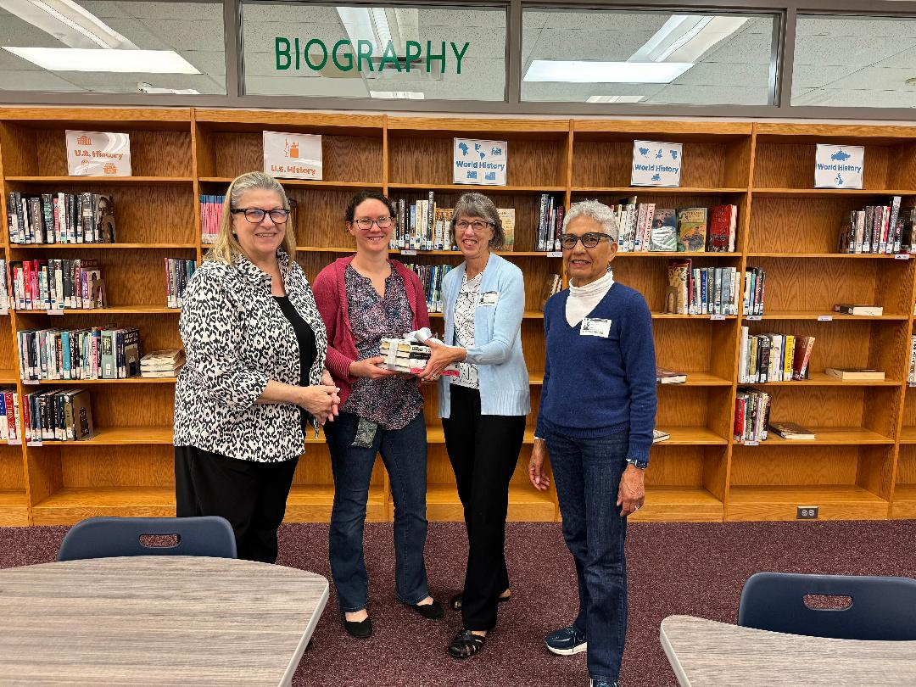

2024-25 Reston Herndon Area AAUW Board of Directors

Position | Officer
*Administrator | Janine Greenwood
*Treasurer | Ruth Ruttenberg
*Secretary | Stephanie Abbott
*Membership | Open
*Program | Open
AAUW Funds | Stephanie Abbott
Adopt A Spot | Fran Lovvas
Book Group | Carla Heymsfeld
 | Alyse Goldman
Cultural Arts | Carol Flicker
 | Roberta Sherman
 | Joyce Senger
Diversity, Equity and Inclusion | Patty Hagan
Education Committee | Roberta Sherman
Historian | Open
Newsletter | Roberta Sherman
Public Policy | Shyamali Hauth
Website Manager | Dianne Mero
Zoom and Weekly Updates | Janine Greenwood

* - Voted positions, all others are appointed

2023-2024 Leadership

Administrator Cyndi Shanahan
VP Finance Ruth Ruttenberg
VP Membership Judi Polizzotti
VP Program Judy Helmich
Secretary Vacant
AAUW Funds Stephanie Abbott
Adopt-a-Spot Fran Lovaas
Cultural Arts Carol Flicker, Joyce Senger,
Roberta Sherman
Book Group Alyse Goldman & Carla Heymsfeld
Diversity, Equity, Inclusion Patty Hagan
Great Decisions Judi Polizzotti & Judy Skirbunt
Newsletter Roberta Sherman
NOVA Liaison Jean Ann Linney
Public Policy Shyamali Hauth
Website Dianne Mero
Zoom and Updates Janine Greenwood

AAUW Diversity Statement: In principle and in practice, AAUW values and seeks an inclusive membership, workforce, leadership team, and board of directors. There shall be no barriers to full participation in this organization on the basis of age, disability, ethnicity, gender, gender identity, geographical location, national origin, race, religious beliefs, sexual orientation, and socioeconomic status.

Vision: Equity for all.
Values: Nonpartisan, Fact-based, Integrity, Inclusion and Intersectionality

Branch Website: http://restonherndon-va.aauw.net VA3035
AAUW VA Website: http://aauw-va.aauw.net AAUW Website: www.AAUW.org Branch Facebook Page: Reston-Herndon Branch of AAUW

