READY TO JOIN?
Have questions about what we do or how you can get involved? We can help. Contact us.

Choose Your Branch and Complete Your Application:
https://aauw.org/membership/
Contact Us:
https://aauw-va.aauw.net/contact-us/
AAUWVAcontactus@gmail.com

www.aauw.org
1310 L St. NW, Suite 1000
Washington, DC 20005
(800) 326-AAUW (2289)
(Monday–Friday, 10 a.m.–5 p.m. ET )

connect@aauw.org facebook.com/AAUW.National @AAUW @aauwnational
@aauwnational

AAUW of Virginia
On March 27-28, 1925, 16 years after the first AAUW branch in Virginia was established in Richmond, a
group of women from the seven state branches assembled in Williamsburg, Virginia, and formed an AAUW Virginia state organization. There are
currently 24 AAUW branches in Virginia with 5,680 members and supporters. Each year AAUW of Virginia holds a conference and a leadership meeting, and gathers in Richmond for a lobby day.

Learn more here: https://aauw-va.aauw.net/

https://www.facebook.com/AAUW-of- Virginia-182801968411607/

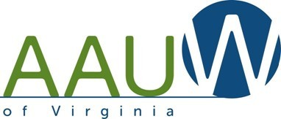

Advancing Equity
for Women and Girls
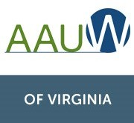
Join us!
WHY AAUW? AAUW breaks down barriers for women in education, in the workplace, and in our communities—locally, regionally, and globally. Whether we’re sponsoring the nation’s largest leadership conference for college student women,
Local Branch Contact Information
representing women and girls worldwide with our consultative status at the United Nations, or boldly striving to reach pay
equity in the United States by 2030, AAUW
is leading the charge to help women and
girls thrive.
Take up the issue that’s closest to your heart and we’ll connect you with the
people, programs, and resources you need to make a difference in the lives of women and girls.

WHY YOU? Your voice and your ideas are powerful. Maybe you’d like to empower local college women to be leaders or help a woman in your
community get paid fairly.
We know you’re balancing a busy life. That’s why
AAUW membership is simple; you can be as involved as you want to be.
It takes only one voice to start making a change.
Imagine how much stronger that voice grows when joined by 170,000 friends nationwide!
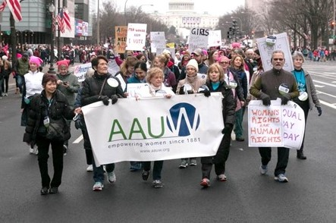
We empower women. You can help. Join us.
What We Do
EDUCATION & TRAINING Addressing the barriers and implicit biases that hinder advancement of women: Education helps women develop skills and knowledge as a pathway to

professional opportunities and economic security. Since 1888, AAUW has awarded more than $115 million in fellowships, grants and awards to more than 13,000 women and organizations in 145
countries to further their academic or career paths and lift up their communities. AAUW’s work on Title IX protects students from discrimination and violence at school. Use AAUW resources to pro- mote equity in education in your community.
ECONOMIC SECURITY Ensuring livelihoods for women: Women still don’t have equal pay and there are too few women in the highest-paying fields. We must create inclusive career path-

ways to attain economic security. AAUW members are committed to achieving pay equity. Get in- volved in AAUW’s goal to train 10 million women in salary negotiation by 2022.
LEADERSHIP Closing the gender gap in leadership opportunities: Women are outnumbered by men in the most prestigious positions, from Capitol Hill to the boardroom. When we cultivate
women leaders today, we create a brighter tomorrow. It is time for women’s voices to be heard. Let AAUW amplify your voice from the statehouse to the Capitol, or advocate for leadership opportuni- ties for women in your community.

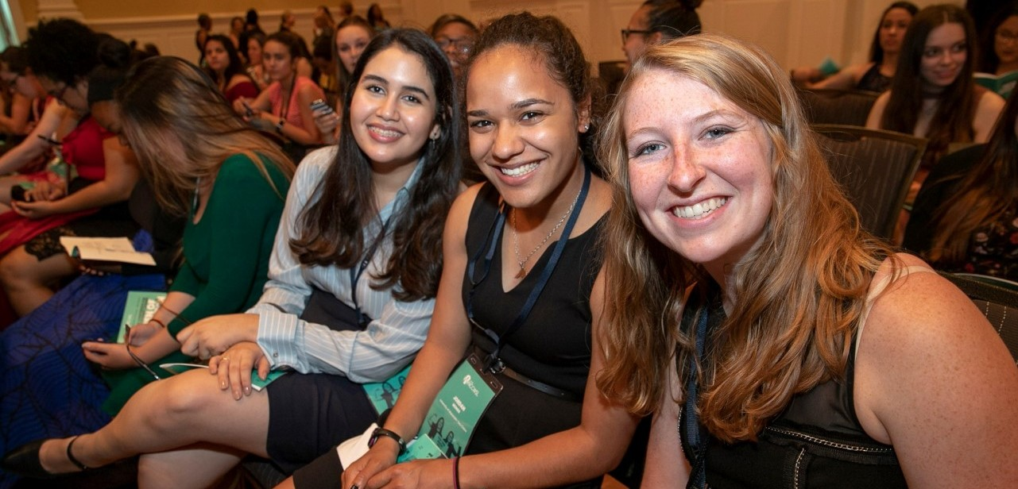

MISSION: To advance equity for women and girls through research, education, and advocacy.
VISION: Equity for all VALUES: Nonpartisan
Fact-based Integrity
Inclusion and Intersectionality

